The guiding principles behind the ACE Coaching Certification Program are:

**A-**chieve: A certain level of knowledge.   
**C-**ertify: To confirm that a coach has obtained a level of

understanding over that which he/she has been tested on.   
**E-**ducate: To assist with the gathering of knowledge and information.



Not sure what to do once you get there!?! Instructions can be found below: 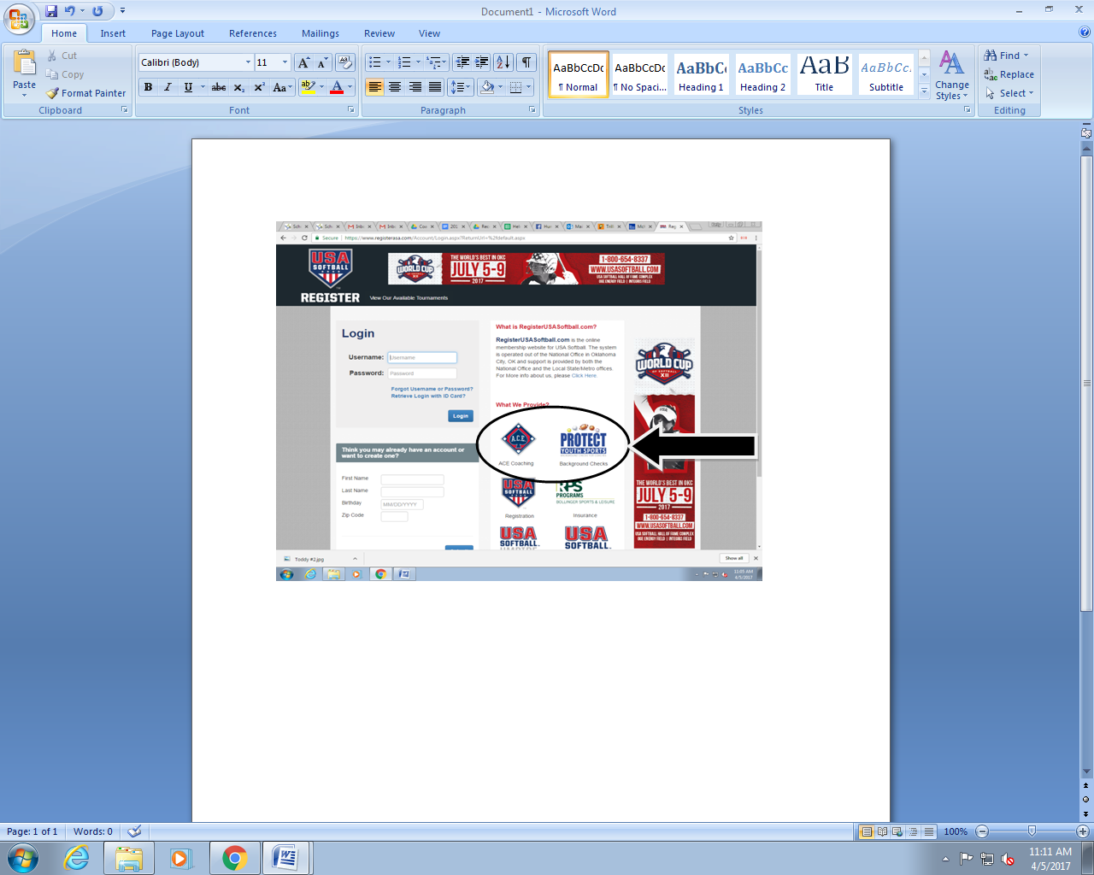

***Simply follow the instructions and you are good to go!***

*\*Humboldt Fastpitch will reimburse you for the exam so please submit:*

*1) a printed copy of the invoice, 2) a copy of your ACE Coaching Card!*